MALINI KISHORE SANGHVI COLLEGE OF COMMERSE AND ECONOMICS
VILE PARLE (W), MUMBAI-400049

Students’ Satisfaction Survey Report

2020-2021

This document is the property of Malini Kishor Sanghvi College of commerce and economics and is confidential. Therefore, it may not be photocopied, either in part or in full, or shown to any person not directly associated either with the process, or with the concerned committee, or with the concerned authority.

TABLE OF CONTENTS

Sr. | Title | Pg
1 | Introduction | 4
2 | Objective of the study | 4
3 | Methodology | 5
4 | Analysis | 7

“If you value it, measure it".
Jack Welch C.E.O. (General electric)

- Introduction
- Objectives
- Methodology

Introduction: Student’s aspirations and goals change in a fast-changing world. That system of higher education, which is ready to honour them and shape its curricular and administrative performance accordingly, will only remain relevant. Students are the most important stakeholders of higher education systems. The interest and participation of students at all levels, both in, internal quality assurance and in, external quality assurance has to play a central role. As experts put it, higher education is foremost about the enhancement and empowerment of students as participants in a process of learning. Even more so, higher education is about participation in a process of learning for transformation. Any Higher Education Institution needs to ensure that student have a voice in various decision making processes, formulating learning and teaching practices and that views of students are to be considered as the primary evidence on which the quality of teaching is evaluated.

Objectives: The student feedback is basically about institutional practices, processes and frame work that take into account concern for the quality of the education they receive. Keeping above in mind following objectives were set.
- To provide the students a greater role in the teaching-learning process,
- To develop a sense of greater responsibility and belonging to the institution among the students,
- To open a transparent communication channel between the student and the teacher, and
- To maintain the functioning of teaching-learning process in the best possible way.
Methodology: Now it has become the ‘system’ in our college to take the feedback of students. The questionnaire (National Assessment and Accreditation Council (NAAC) Student Satisfaction Survey Key Indicator - 2.7.1 Under Criterion II of Teaching – Learning and Evaluation) form consists of questions related to perception and thought of students about the overall teaching and learning. The population of study was all regular students studying at Malini Kishor Sanghvi College of Commerce and Economics. The survey form was sent to all the students to their registered e-mail i.d. together with covering letter.
For online survey, students were informed about this system at beginning through adequate notice and they were encouraged to give their honest responses. In order to build confidence and to maintain confidentiality of students identity, personal identification like name, roll number were not required to be written on the questionnaire. SSS online survey form were sent to all students through e-mail and students were asked to fill the form before stipulated data. They were again informed to fill the questionnaire without fear or prejudice. In all 286 students have participated in survey. Data entry was done in MS Excel (version 2007, Microsoft Corporation Ltd.) and analysis was done using statistical software Minitab (version 17).

“A number speaks for thousand words”.
&
“A graph speaks for thousand numbers”.

Analysis of Students Satisfaction: As given in questionnaire, 21 questions / attributes was considered for survey and analysis (Student Satisfaction Survey (Key Indicator 2.7.1) Under Criteria II on Teaching – Learning and Evaluation.)

Pie diagram is plotted for each of the questions / attributes displaying the distribution of opinion of students. The mean, standard error, first quartile, median, third quartile and modw score for each questions / attributes is calculated and the overall mean is arrived at. This figure will range from 4 to 0 and will give the mean satisfaction level of the students for the particular institute.

Q.No.1 How much of the syllabus was covered in the class?
4 – 85 to 100%
3 – 70 to 84%
2 – 55 to 69%
1– 30 to 54%
0 –Below 30%

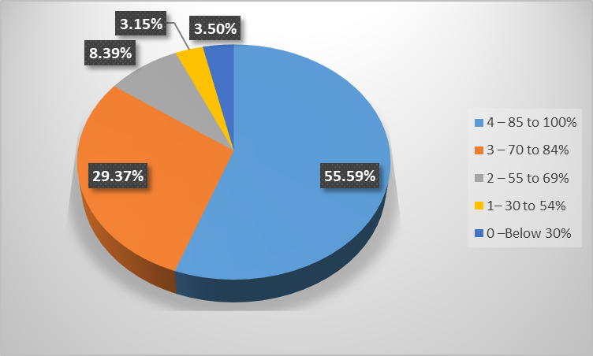

Mean | Standard Error | First Quartiles | Median | Third Quartiles | Mode
3.30 | 0.06 | 3 | 4 | 4 | 4

Q.No.2 How well did the teachers prepare for the classes?
4 – Thoroughly
3 – Satisfactorily
2 – Poorly
1 – Indifferently
0 – Won’t teach at all

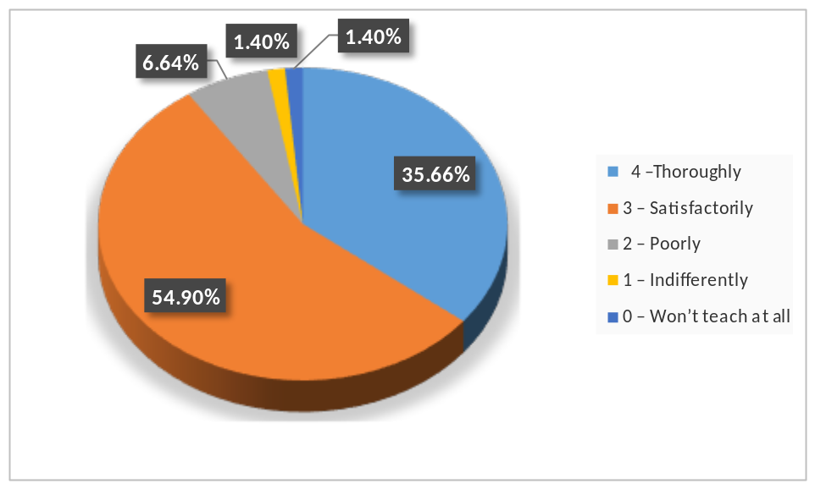

Mean | Standard Error | First Quartiles | Median | Third Quartiles | Mode
3.22 | 0.04 | 3 | 3 | 4 | 3

Q.No.3 How well were the teachers able to communicate?
4 – Always effective
3 – Sometimes effective
2 – Just satisfactorily
1– Generally ineffective
0– Very poor communication

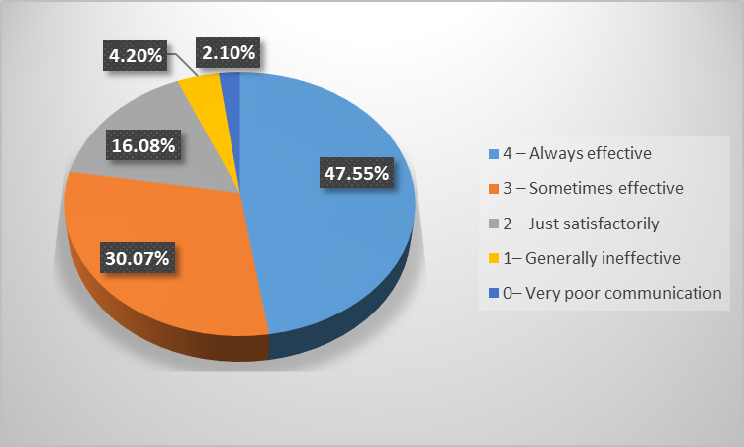

Mean | Standard Error | First Quartiles | Median | Third Quartiles | Mode
3.17 | 0.06 | 3 | 3 | 4 | 4

Q.No.4 The teacher’s approach to teaching can best be described as
4– Excellent
3 – Very good
2 – Good
1 – Fair
0– Poor

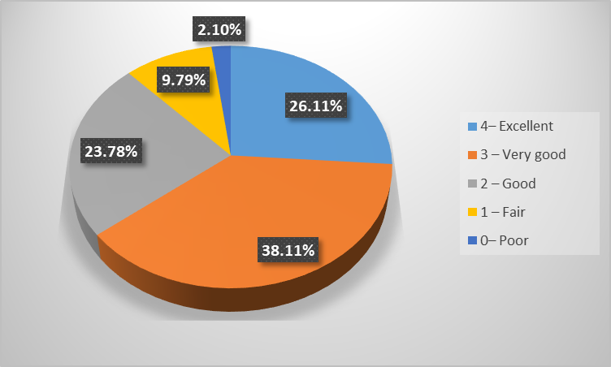

Mean | Standard Error | First Quartiles | Median | Third Quartiles | Mode
2.77 | 0.06 | 2 | 3 | 4 | 3

Q.No.5 Fairness of the internal evaluation process by the teachers
4 – Always fair
3 – Usually fair
2 – Sometimes unfair
1 – Usually unfair
0 – Unfair

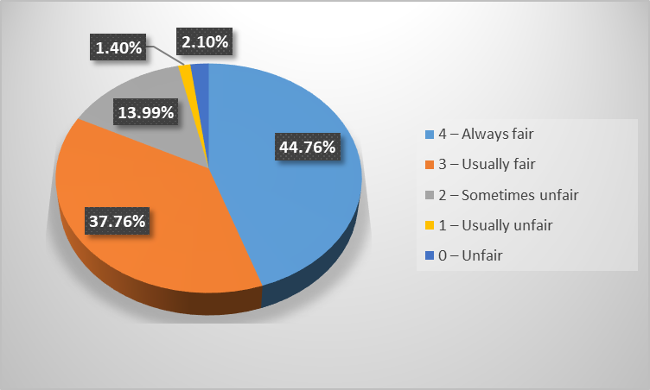

Mean | Standard Error | First Quartiles | Median | Third Quartiles | Mode
3.32 | 0.05 | 3 | 3 | 4 | 4

Q.No.6 Was your performance in assignments discussed with you?
4 – Every time
3 – Usually
2 – Occasionally/Sometimes
1 – Rarely
0– Never

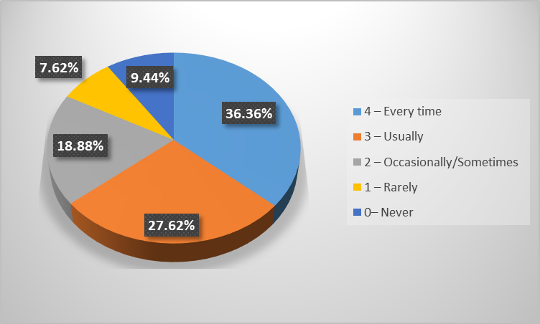

Mean | Standard Error | First Quartiles | Median | Third Quartiles | Mode
2.74 | 0.08 | 2 | 3 | 4 | 4

Q.No.7 The institute takes active interest in promoting internship, student exchange and field visit opportunities for students.
4 – Regularly
3 – Often
2 – Sometimes
1 – Rarely
0– Never

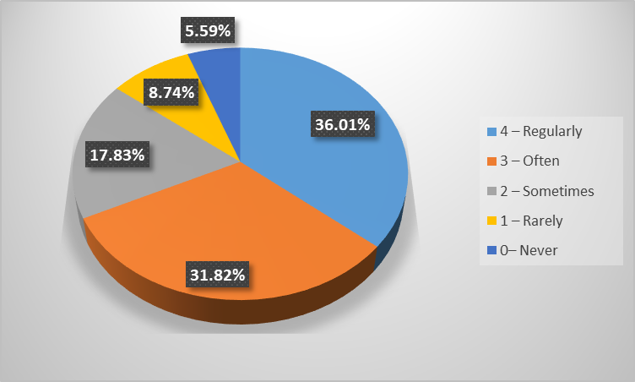

Mean | Standard Error | First Quartiles | Median | Third Quartiles | Mode
2.84 | 0.07 | 2 | 3 | 4 | 4

Q.No.8 The teaching and mentoring process in your institution facilitates you in cognitive, social and emotional growth.
4 – Significantly
3 – Very well
2 – Moderately
1 – Marginally
0– Not at all

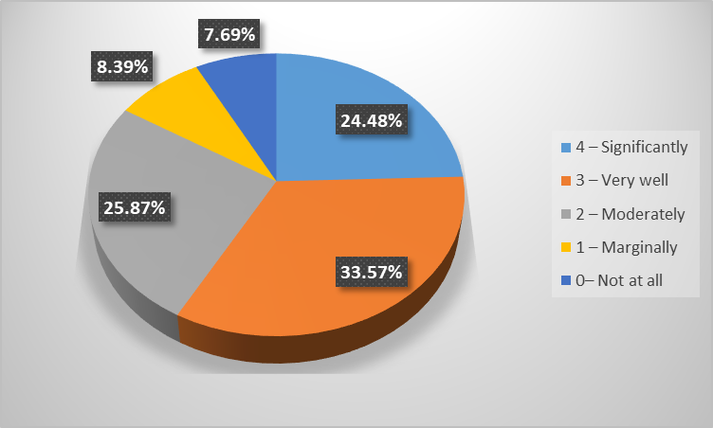

Mean | Standard Error | First Quartiles | Median | Third Quartiles | Mode
2.59 | 0.07 | 2 | 3 | 3 | 3

Q.No.9 The institution provides multiple opportunities to learn and grow.
4 – Strongly agree
3 – Agree
2 – Neutral
1 – Disagree
0– Strongly disagree

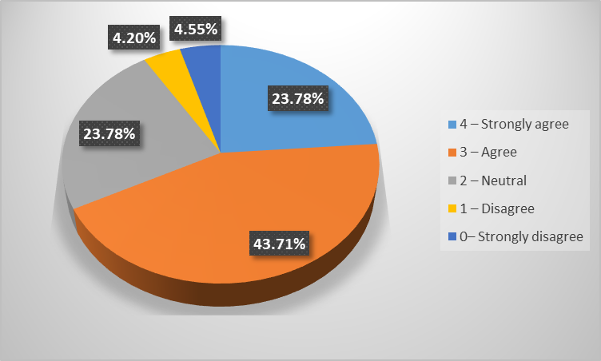

Mean | Standard Error | First Quartiles | Median | Third Quartiles | Mode
2.78 | 0.06 | 2 | 3 | 3 | 3

Q.No.10 Teachers inform you about your expected competencies, course outcomes and programme outcomes.
4 – Every time
3 – Usually
2– Occasionally/Sometimes
1 – Rarely
0– Never

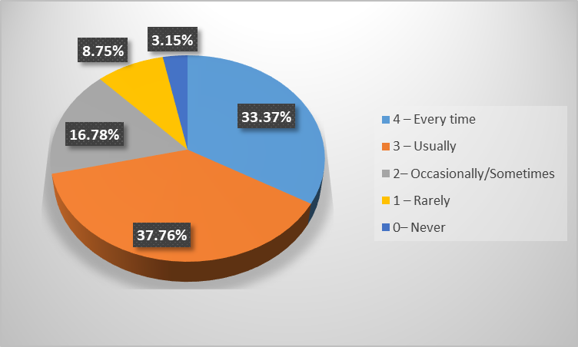

Mean | Standard Error | First Quartiles | Median | Third Quartiles | Mode
2.90 | 0.06 | 2 | 3 | 4 | 3

Q.No.11 Your mentor does a necessary follow-up with an assigned task to you.
4 – Every time
3 – Usually
2– Occasionally/Sometimes
1 – Rarely
0 – I don’t have a mentor

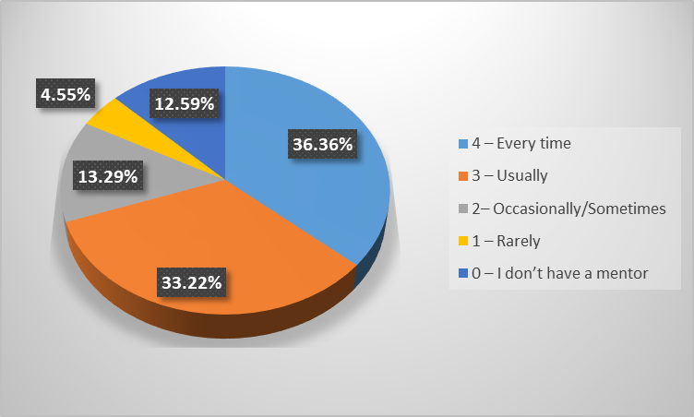

Mean | Standard Error | First Quartiles | Median | Third Quartiles | Mode
2.76 | 0.08 | 2 | 3 | 4 | 4

Q.No.12 The teachers illustrate the concepts through examples and applications.
4 – Every time
3 – Usually
2– Occasionally/Sometimes
1 – Rarely
0– Never

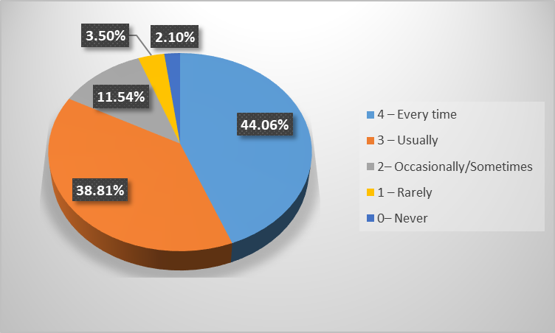

Mean | Standard Error | First Quartiles | Median | Third Quartiles | Mode
3.19 | 0.05 | 3 | 3 | 4 | 4

Q.No.13 The teachers identify your strengths and encourage you with providing right level of challenges.
4 – Fully
3 – Reasonably
2 – Partially
1 – Slightly
0– Unable to

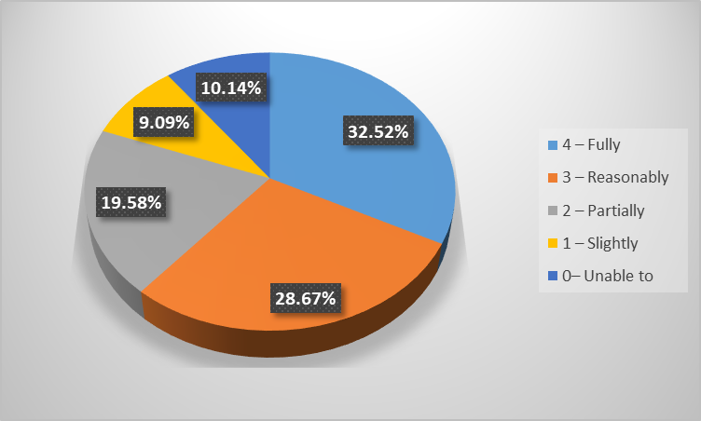

Mean | Standard Error | First Quartiles | Median | Third Quartiles | Mode
2.64 | 0.08 | 2 | 3 | 4 | 4

Q.No.14 Teachers are able to identify your weaknesses and help you to overcome them.
4 – Every time
3 – Usually
2 – Occasionally/Sometimes
1 – Rarely
0 – Never

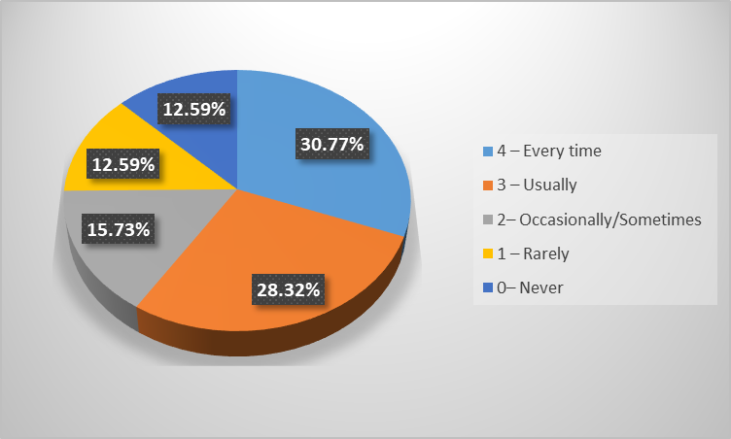

Mean | Standard Error | First Quartiles | Median | Third Quartiles | Mode
2.52 | 0.08 | 1 | 3 | 4 | 4

Q.No.15 The institution makes effort to engage students in the monitoring, review and continuous quality improvement of the teaching learning process.
4 – Strongly agree
3 – Agree
2 – Neutral
1 – Disagree
0– Strongly disagree

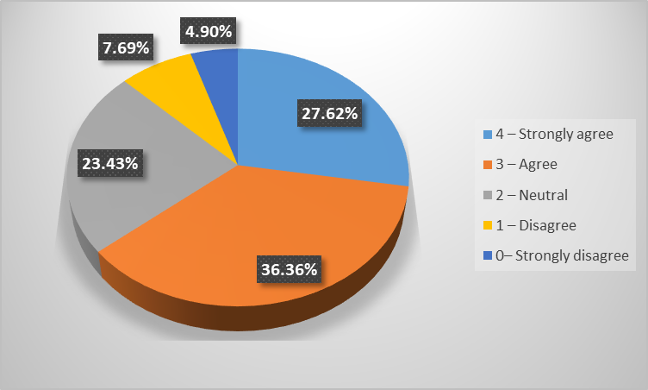

Mean | Standard Error | First Quartiles | Median | Third Quartiles | Mode
2.74 | 0.06 | 2 | 3 | 4 | 3

Q.No.16 The institute/ teachers use student centric methods, such as experiential learning, participative learning and problem solving methodologies for enhancing learning experiences.
4 – To a great extent
3 – Moderate
2 – Some what
1 – Very little
0 – Not at all

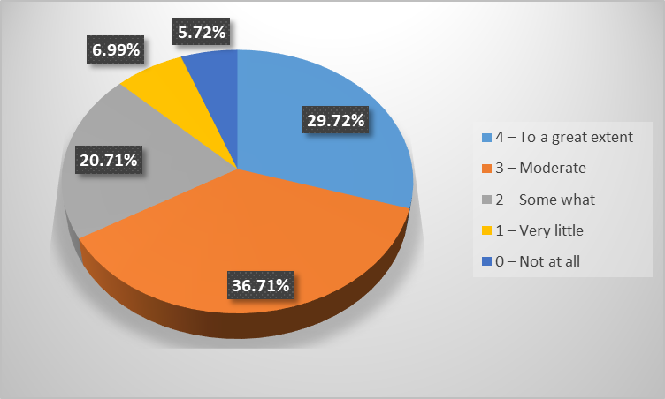

Mean | Standard Error | First Quartiles | Median | Third Quartiles | Mode
2.77 | 0.07 | 2 | 3 | 4 | 3

Q.No.17 Teachers encourage you to participate in extracurricular activities.
4 – Strongly agree
3 – Agree
2 – Neutral
1 – Disagree
0– Strongly disagree

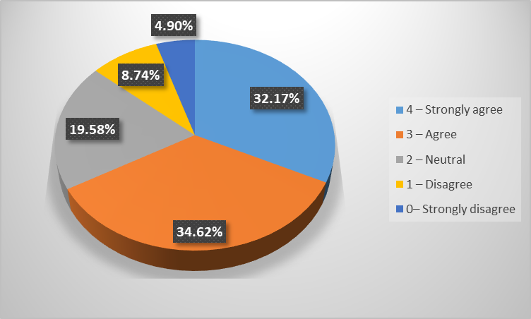

Mean | Standard Error | First Quartiles | Median | Third Quartiles | Mode
2.80 | 0.07 | 2 | 3 | 4 | 3

Q.No.18 Efforts are made by the institute/ teachers to inculcate soft skills, life skills and employability skills to make you ready for the world of work.
4 – To a great extent
3 – Moderate
2 – Some what
1 – Very little
0 – Not at all

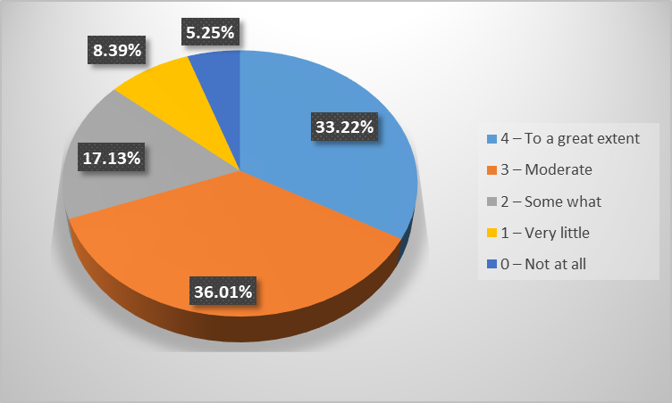

Mean | Standard Error | First Quartiles | Median | Third Quartiles | Mode
2.84 | 0.07 | 2 | 3 | 4 | 3

Q.No.19 What percentage of teachers use ICT tools such as LCD projector, Multimedia, etc. while teaching.
4 – Above 90%
3 – 70 – 89%
2 – 50 – 69%
1 – 30 – 49%
0 – Below 29%

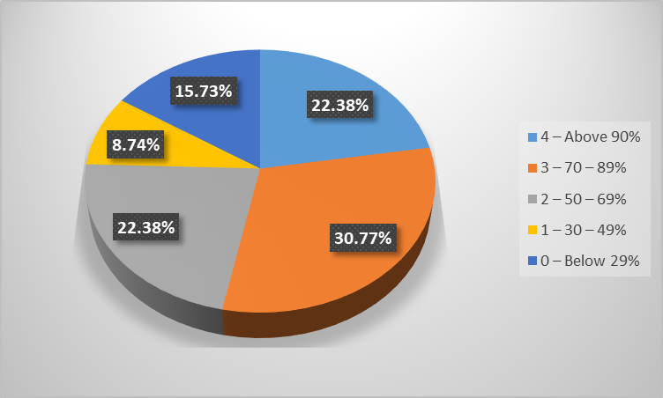

Mean | Standard Error | First Quartiles | Median | Third Quartiles | Mode
2.35 | 0.08 | 2 | 3 | 3 | 3

Q.No.20 The overall quality of teaching-learning process in your institute is very good.
4 – Strongly agree
3 – Agree
2 – Neutral
1 – Disagree
0– Strongly disagree

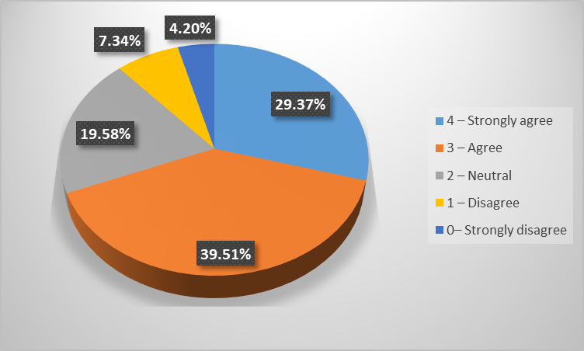

Mean | Standard Error | First Quartiles | Median | Third Quartiles | Mode
2.83 | 0.06 | 2 | 3 | 4 | 3

The students are asked to give three observations/suggestions to improve the overall teaching-learning experience in the institution. This would provide an idea of the general expectations, observations and suggestions from the students. Following suggestions are observed from students:
Question bank for exm
Okaish
The teachers can find some new ideas for teaching like showing some videos for explaining a particular concept.
That the teachers should learn to include the use of technology in there teaching methods.
I had a wonderful experience in college. Teachers are good and supportive.
some teachers are very interactive and very good at what they do while some are little less. but overall everything is going well
There should decrease in college fees
the teachers have been really unhelpful with some situations like fee paying troubleshooting, mks college have made very bad impression as well as many students were facing problems and college nor teacher were properly responding about it. even after students visiting the college, faculty were not helpful and just made students go to one department to another.
Firstly, The fees for this year 2020-21 was too high keeping the covid scenario in mind.
The faculty of my college is very helpful and experience. They not only help in academic but also prepare us for life.
More interaction between students and teachers
Make it more fun and interesting
Teachers are really helpful here.
Quality of teaching - learning process is good.
Very nice
there should be more of practical learning rather than just watching power point presentations.
Learning some concepts in game/activity or funway
EVERYTHING IS AS PER MY SATISFACTION
GIVE CASE STUDIES
Good
Clean Internet
Good
Do more practical such as presentation
The Professors are great
I suggest students to attend as our teachers are taking so much effort to make each every student understand
Change Collage facilities
Being student friendly
Eye fatigue prolonged lectures
Not too much but please work on technical issues.
Better infrastructure
During the lec teacher says, if you have any problem u can tell me I will solve your problem. But when the real problem arrives and we confront them they bail.
After experiencing the way online lectures are conducted, I wish the method of teaching practical subject improves!
It is possible by making sure everybody solves the practical problems or even gives their input with which the lecture gets way more interactive.
Teaching Techniques
Making students learn in more fun way.
Good teacher
It would really be great if the college and staff would take more responsibility and make student feel like they belong to that institution
Classes should be more actively engaging and not only students listening to teachers lectures.
It is awesome. no suggestions....
Non
Teachers should be more interactive
Charge high fees
Happy with teaching method of staff.
More interaction
Making it more interesting rather than just explaining the whole content
They should explain the syllabus properly with examples.
Syllabus should be covered properly
Please provide students with AC
In accounting teachers should know that are there students understanding their methods or not !
The teachers are excellent and make learning stress free as much as possible, I personally wouldn’t know a better way of suggesting any ways to improve teaching because the teachers are so considerate.
Focus more on practical
More discussion between teachers qnd students
Nothing special is needed only percentage of attendance should be improved
Understanding that we are studying online which is not the same as offline and responding in a suitable manner
My Learning experience in malini kishor sanghvi college of commerce and economics have been great the faculty here makes sure that students understand everything and does not lack behind in any aspect.
There should be more opportunities for internship for growth of students and internships should be checked and verified before going forward to students
Internships should be provided
Things can be more organised
Overall great experience
Please change from online to offline
More use of Projectors
More good quality of teaching, that students can learn more effectively.
can go with ICT and prjoectors for effiecient learning
Teachers/Professors should first of all explain the importance of the education, in between based on the reaction of students, they should identify the students who are willing to learn & should focus on them.
Keep attendance of the students
Everything is good
Help students to analyse their strengths and weakness
Use better graphics and visual media to engage students well.
They are better
Improve infrastructure of the college, inculde projectors in all the classrooms. All the classrooms are not equipped with projectors but all the self financed courses have a similar fee structure.
Expert faculty members should conduct seminars in respective field
Firstly, please try to discuss the entire syllabus on the very first day and don't just start teaching.
It is pretty good
Attendance must be super stict
Nothing
Fees is slightly high then what the college should take especially during such pandemic. Students should pay fees only for facilities that are provided by the college. Overall fees could be reduced considering zero accessibility to gym, library, classrooms, grounds,etc
New technology
Can explain assignments better
Teachers are taking active interest from there side even though the online platform is difficult to operate.
It's good
The teachers should pay attention whether all the students are added in groups or not while giving group projects.
Introverts need to be taken care of. Teachers should also look into the problems faced along with the academics. Especially the teacher for ITA.
The college took 40k fees but still teaches from youtube then what’s the use?
Can have more interactive classes
Due to pendamic. I don't think my any suggestion matters
Assignments and Grp Projects
Provide collaboration and socialization opportunities.
None required
One to one discusssion should be done.
It's good
Can do better
The teachers should make the lect more interactive rather than sticking to the ppt or book
Online studies is less interesting and offline is preferable becuse in pffline people do get serious about studies and online lectures usually dont help
Good teaching
E-books for easy learning
Everything is good
Nothing
To be more interactive
We can use more videos and pictures for better learning and teaching.
Overall is good
Plz put lift in college
Don't pile up assignments on students
By keeping lectures more interactive and giving more of practical knowledge.
By always using power point presentation. It get easy for us
Need more regularity in lectures
It is great being a part of this college
Need to improve management
Communication
More of the practical world practices should be included while teaching.
Use lcd projector
There should be air conditioners in every classrooms.
Everything improved
Good
All is good
Teachers are good but if they try to inculcate more time towards personal training for weaker students then it'll be well
Teachers always encourage to students
Good
No suggestions
Teachers should be friendly to all the students
Experienced teamwork
Better infrastructure as compared to fees charged
Teacher should take more interest in teaching
Keeping in mind the current pandemic situation, teachers should reduce explaining the syllabus with the help of just PPTs because it becomes difficult for students to concentrate on PPTs for such long duration.
Teachers should show some practical videos more often then just online lecture
Give more practical knowledge
Make two way interactions.
College should provide internships.
Giving examples to make it more easy way to understand
Teacher's should focus more on practical examples whenever and wherever possible
Ofcourse it's online so it can't really be possible
None
Teachers are all good and experienced, But I think that this online curriculum is not well suited because few teachers cannot explain properly. At least that's the reason I think.
the teachers teaching was very good
Since its online..teachers should try to teach a little more.
Good
No suggestion
A good institute
Showing videos related to topics or examples taught in online class rather than just explaining it orally as visual learning makes learning more interesting and makes it easy to memorize.
More and more interactiveness
Better classroom
Use of more videos and live examples for making teaching and learning more interesting
Everything is good
Everything is good
Interaction level should be increased
It's going good
No need to improve
Should give study material
Less YouTube video during online classes
Activities
Need good communication and teaching techniques
There's no mentoring taking place.
There's no relationship building between a teacher and student is out most unbothered .
1) The teachers should provide notes as there are only few books available for BIM COURSE
MKS should be more informative regarding the changes in class time table.
Interactive class
More of PPTs must be shown as it makes the topic interesting and we can remember the concept for longer period.
Teachers could teach more understandable
ask every student to answer
More MCQ practice if college continues online
To not expect students to learn everything in a stretch and give them frequent breaks if they have 2 continuous lectures.
Should give more study material
Syllabus need to teach in average speed not to target that need to complete syllabus only
The teachers should be more understanding towards low attendance as majority of the students are doing professional courses as well.
college should be started with less number of student we could be able to under stand
Institute is doing very well in these tough times and helping students in all the possible ways
Practical work is required
Overall experience is great
Some creative work
MORE OF AN INTERACTIVE LECTURE
Classes should be more engaging
Teachers should explain more deeply the topic
Everything is good
Teachers dont move forward with concept until last person understood... so thats a good thing
Should start portion on time nd don't go fast wd the portion
1) To explain the subject more
None
Few professors need to change their way of teaching in online class
Live examples
More engaging with students
Would like if the institution /teachers could give us more knowledge about internships, job opportunities and placement.
All good
Revision of what is done should be taken in a week or A month
Lcd projector to be used.
Could use more real life example to make the concept interesting
Can be done better in teaching with taking fees
Offline lectures
It should be more practical sudy than theroy based
Nice
Be polite
Assignments could be explained in a more systematic and precise way.
The teachers are very good and efficient
Make teaching a two way of interaction
According to the fees we are getting nothing to learn comparatively other college students are well informed
All professors have high ego since they control our marks, and for that matter they purposely take advantage of the student and just waste time giving them useless assignment and don't give them marks at the end of the day.
Please tell Rushi Sir- Cost Accounting sir to stop showing Youtube videos in the entire lecture and try to teach by himself and not rely on someone else's content
Placement for students who are appearing for CA exams
Teacher should be cheerful
increase in atttendance
If online probably they should ask students to switch on the camera so it makes the students also a little excited
Teachers are just coming for college satisfaction not as a teacher
I have very low self confidence in my self and I also have no social life our college takes a lot of fees unnecessarily and can’t even put ac in our class:(
More interactive sessions instead of just a lecture with explanation
Teaching is bad compared to other colleges. It can be changed if teachers reallt care about students and enagage them into learning with different techniques. They should care about students. I have never got any personal evaluation neither did any teacher care about our future. No one values this degree because it came from MKS college. The value of knowledge is zero.
Teachers are very friendly
A little regularity in lectures and exam schedules
This is not a suggestion but I am very satisfied with my teachers and find that learning is enjoyable as the teachers are friendly, skilled and not unnecessarily strict.
Every mentor should use ppt to explain the lesson
sometimes the teachers are partial towards a few students, there should be equality.
It was a good path of my life that i have studied in malini kishor sanghvi colleg were teaching, and hospitality was at the other level like sitting at our own home
The classes are going great no opinions
Every thing is perfect no need for any improvement!!!
Nothing to improve
nothing
Better teaching techniques That are both engaging as well as interactive.
No improvement needed
Excellent
Its already improved
Teachers should be on time and inform before cancelling the lectures.
Teacher are late in online meeting
High fees
If the institution could provide more practical knowledge along with the usual syllabus for making the students work ready.
Observation-
Teachers teach for the sake of teaching not becau
Teacher are very knowledgeable, they are always been there for a doubt or any queries .
Please give students their Results
They should be more strict. Because of Leniency most of students does not care about study.
It should be interactive, alot of teachers don't even interact. It gets boring.
In online lectures students should get proper email if and password from teams to login which makes it easier and not check mails everyday
Good
Mentor should be helpful towards the student instead of scolding them when they need there help.
Make attendance compulsory
Offline class
Fees are very much high should be neutral
Need to be more interactive with students
Better infrastructure facilities
The teachers are perfect in teaching, the use of ppt and videos are used highest which makes the understanding better.
Good! But there are some teachers who just read and don't explain anything which is difficult for many students.
The students should be informed when the classes are not happening.
Need to improve teaching skills
Last year the lecture were online so there wasn't much interaction.
Professors were good in teaching online
More internship
All Teachers are not still fully acquainted with the online process so college could conduct a workshop on this.
Very good
The institute charges way more than any other institutions still there's no air conditioning in classrooms due to which a student is unable to focus
Improve the sound quality and network quality in the college
Communication between teaches or college & students have be improved.
Sharing of course requisite notes.
The Institute should start with college cultural programs and the teaching method that is the camera of the students and teachers should be on thus that would make the learning more effective and interesting
Improve the IT department
College takes extra fees in such times and lab fees from commerce students,!!!
Great time of UG learning
It is a best college, ... all availability material of IT gadgets are best .
Presentations for internal assessment!
Time is mismanaged and eventually presentations are given just for name sake. I remember putting my heart and soul in my assignment, and a professor who shall remain nameless, told us to finish a 10 slide presentation in 3 minutes. Now how on earth is that possible? All this eventually leads to doing the assignment just for the sake of it, doing a poor job and incompetent presentation skills. Which kind of defeats the purpose. And I know, I am not being heard. If I am, I want a confirmation email saying yes, we will work on this aspect.
More activities can we taken.
More practicality while teaching then bookish reading.
good
If we are paying the amount of money and nothing is been taught it’s disappointing. They literally do the surface studying and act like we were born to already know this.They should be making us job ready but they’re making us home ready. We have developed absolutely no skills here.
There was always delay in providing the timetable or the student id.
It is very undisciplined and unorganized.
The teacher really needs to learn what they are teaching they are taking 2 subjects per semester and teaching absolutely nothing and expect students to do practical, viva and case study on it. For a course like BSC(IT) the teacher are poorly educated and have no idea how to teach the subject they just come to the lecture for sake of coming and don't teach what should be thought.
Being honest there is no need to improve the overall teaching as the teacher’s did it well
Everything is great about the college except full fees was taken even during the pandemic
The softwares used are outdated should be up-to-date
Problem solving skill improvement of students
No need to
give every student equal attention
Results allocation process should be better and prompt
Student interaction at personal level atleast once a year
Burdening students with many assignments at a time should be avoided.
Communication
None
I don't have any problem with teaching but when I ask help other then studies like filling college admission form I don't get proper response. So I will suggest to help student other than studies.
Could give us sap id's for teams. We were told we could see the recorded lectures on Microsoft teams but we cant even login because the college dosent want to give us a Microsoft teams sap id's
The teaching and the professor's are really gooda and I don't have nay issues with respect to academics, the only change I want is in the admin department, because it's a lil slow and back headed than the other colleges.
Giving more attention to students
To be honest there should be a change in the education system!!
Try and take suggestions of the students if they are trying to help the teacher so that their teaching improves and the students also understand the concepts in a better way.
There has not been any quality time other then studies between students and many of new joiners have no clue about how this system works. i think teachers should take a front step in this and introduce the whole class to group activities in order to socialise with other fellow students and work on teamwork
The institution does not have basic facilities like clean washrooms for students and good infrastructure
Our management is to be blamed in this pandemic. Every college have reduce fees or atleast not increase fees. But the management in this difficult time not only refuse to decrease the fees but instead increase the fees of the current year. Despite our request and protest to reduce fees nothing happened. Our college didn't even consider our request and ignore us. Many parents have lost their jobs, unluckily many students parents are not with us and that have been to a great concern to us. In this financially crick year we dint expect to not take fees, we just requested a reasonable deduction in fees for one academical year and they could have done that but instead they hiked up the fees. This was very unfair for many students. It was ethically wrong.
Make it interactive
Our college should increase the facilities in campus.
the information regarding college work should be more clear.
Career guidance lectures
PLEASE KEEP UPLOADING COLLEGE WEBSITE AND INFORM THEM ABOUT SPORTS TEAM SELECTIONS LIKE FOOTBALL BY EMAILING THEM.
Good
Clear voice
Sometimes network issue
make learning difficult concepts more fun
Syllabus can be completed on time
There are no suggestions
Change Collage staff
Not being too harsh to students
Few change in teaching faculties
The worst teacher that I have faced in Mks is our maths sir Mr Sudhakar. He one day out of the blue he omitted the whole portion for the internals and expect us to respect him for doing that. And always embarrassing the students in front of whole class. And what the students are doing in their personal life should be non of his concern.
Null
Behavior
Overall is good
Need good interaction
The teachers could share a regular feedback for improving skills and not just theoretical knowledge
Because of the Pandemic, the institute can take up several online activities for students well being and happiness.
More fun activities
Providing with regular notes after each lecture
Teachers should put more efforts
Usually our college teachers are well communicated with students
Give homework
More curricular activities
Trying to keep the class more interesting rather than forceful and threatening regarding marks
The online program and examination have been great the teaching and non teaching staff was always available for any queries asked during the examination
Timely coordinating with students regarding their queries
Almost all the teachers are professional, always ready to help and they know their job well
I want to go to the college
Interesting way to teach
Giving more time to students.
instead of showimg youtube videos teachers can themselves explain is the theory
In INDIA maximum number of students are immature, they have no Idea how important education is for them. They find the education process boring, but because of those students, teachers/professors don’t pay attention to good students also, this is where things goes wrong.
Keep giving assignments
Build a more growth friendly environment
Try to reach every student and ask for their doubts.
I have learned good
College charges fee for gym facilities and computer lab facilities. Inform the students about these facilities and incourage students to use these facilities.
More internships should be introduced!
Please try to bond with the students more like a friend to them.
Fairly provide computer lab facilities to all the students of the college
Nothing
Admin can respond more timely
Sometimes there are technical issues during online classes.
They should create more opportunities to create interest in academics.
Also assignments are given literally 3 days before the due date.
Because the college is doing its best
It should be more of teaching n giving individual attention
There should be more focus on Social Skills
To be more fun learning experience
A/c classes
Let them approach you whenever required
Opportunity
Visitng faculty should be appointed after complete assestment.
Canteen should be renovated.
Sab jhakaa hai
Niceeee
Al
The office administration sometimes not function well with the students
They always give a beat example to better and easy to understand
Very good
Teachers example will explain should be easy and understanding
Nil
Enhanced skills
Teachers need to have better interaction with students
Gaming or quiz session should be conducted which encourages students to attend more often and learn that way.
Try to reach every student and ask for their doubts and try to solve them.
More interaction
Many teacher's just start YouTube and don't really teach
They should rather show YouTube as an example and not as a mode of teaching us, otherwise we can watch YouTube ourselves whenever we want to.
I would like to suggest that the management's management is not so good so they must look into it and try to make student's life easier by giving important notices on time and wit clarity at least.
exams were also good
Good
Case studies
Get in external speakers for first lectures
Question and Answer session should be organised
Good
Amazing teachers
Should have more activities
Topic of ppt from outside textbook should be given
2) If not able to provide the notes they should atleast give us reference of books related the course syllabus.
Attendance should count
And extra credit points should be given to regular students.
make student teacher and let other classmates understand what the student is explaining
Should be more important points
The internals should only be presentation and not vivas as it makes the students more stressed out and creates anxiety because it is online.
Research
THROUGH INTERESTING GAMES ,BACK STORIES CAN MAKE LEARNING EASY
Teacher should explaing giving with an example so its better to understand
Everything is good
A little more guidance regarding internships and jobs will be helpful
2) If a student hasn’t understood the subject the teacher should explain it again
None
Dialer of college should be changed no one receives when needed and unnecessarily far away students need to travel
Keeping it simple not exaggerating the topic
More internships
Would really prefer if the teachers are just not reading from the ppt , but actually make lectures more interesting due to this online environment.
Practical
Partial with all students
Good
More student - teacher guidelines are needed to explain projects.
Use better graphics
Fees structure is too high
As per the fees, there is almost no incentive for the students for the gyms and sports and cultural festivals. Students like to make friends but all tge professor have a problem with that clearly.
Some teachers just speak without sharing any ppt. So it's like listening to an audio rather than an interactive class.
Teacher should be light minded ( cool temper )
supportive
More activities so they interact more than just teaching and going
Very much cooperation and coordination among students and professors
More use of illustrations
Assignment should be given in group
The explanation of our teachers are good understanding
Best
Teachers don't teach the subject they are supposed to teach and play a random youtube video for the whole lecture
Improvement in Teaching by smart board
The institution should host constructive and engaging online competitions for the students during COVID times. For example, a debate or an online chess meet.
The overall learning experience from a teacher perspective they are always been there best and the quality of teaching is little old school but if you keep a close attention you will get the most out of it.
Please give students their Results
Compulsory attendance should be done so all the students attend the class.
Hardly anyone encourages sport.
Books or notes should be provided by the college atleast recommend cause teachers don’t even send ppt or any study material how are we suppose to study.
Teaching facility is good , but sometimes some teachers go faster in the flow so they should ask the students whether they understood the concept or not, not all the teachers are same some of the teachers but even though the teaching is very nice of mks college
Use 360 degree perspective to evaluate students
Improved classroom
Result and notice for examination sholud be on time
Better hygiene
It's good.
Nothing
Must focus on particular student
overall the experience was good
More activities
Sometimes the subjects aren't taught time table wise. Daily changes happen in timetable very often
College should be more clear about the way of teaching learning process like college always give the timetable of lectures at almost the end of the semester, & teacher almost never have any idea of when will be the exam conducted, and the dates for project submissions always extends for unknown reason.
Tell the staff to atleast pick a phone call when a student is calling to college
Faculty is average due to only certain teachers being good
Due to online study their is absence of physically interactions, but professor teaching gives us best examples, and makes us understand
A detailed Review of our internal assessment and presentations, indicating why we got x marks. So we can work on the weaker parts of our assignments and score better in upcoming semesters.
Besides, it's the job of a teacher to help their student grow. What better way to help students grow, by telling them about their strengths and weaknesses?
Certificate programs can be held
More emphasis on examples so that concepts are clear.
better
Should improve every single faculty except math teacher. She’s good. Rest all disappointing.
The principal must take action in appointing proper teacher as we students are paying the highest fees for BSC(IT) compared to other college in mumbai. Totally disgusted by the teachers.
Malini kishor sanghvi college has the best and co-operative teacher and the exprience of online studies was way good with them
Teachers should clear the basics first and then proceed towards advance problems
All good
You guys doing it good
Less fees
More use of multimedia can help us students to grasp learning things faster.
Interaction
No expectations
Some teachers dont even prepare what they are going to teach us they will look it up while teaching us
Awareness about syllabus
Forwarding ppt’s
Needs to improve
The teachers should organize a fun way to understand the topic like a small debate.
Showing more videos for better explanation
Please see the topic
Problem-solving methodology can be used.
The institution lacks time management as timetable for the day is sent 30 minutes before the lectures, results are always delayed
It came to our notice that teachers were frustrated as they receive less salary in covid time even though they received full amount of fees from student.
Play a quiz or something of what they taught
We are getting many internship opportunities from the college .
college administration should be more involved in giving details and up to date things in college and giving regular updates .
UNDERSTAN THE SITUATION IF THEY LOOSE SOMETHING LIKE A MARKSHEET GIVE A COPY WHICH THE ADMIN HAS SO THEY DONT NEED TO RUN TO FILE FIR AND CAN FOCUS ON FINDING A JOB.
Good
Clear screen
No issue
interaction with student and teacher should be more
Nothing more
It's perfect
Change full collage
Actually making students understand rather than shouting and demotivating
Better opportunity for student participation
Some of the teacher just come in the class or during online lecture read from textbook. I can do that at home as well, but I attend lectures to understand the concept better. If I am paying the college for better education the least they can do is appoint a teacher that will explain the concept instead of reading the book out loud.
Null
Use more relevant examples and inspire the kids rather than making them machines.....
Nothing else for suggestion just maintain like this forever
Make more effective
There were sure seminars conducted relating to different fields of work but I think a more practical approach to challenging students for doing creative things would be great
Online college should be a little more interesting to attend by making it interactive and by considering how students will be benefited from it.
And notes
They should help students
I really like that our teachers are not biased towards any students
During projects focus on quality
Sometimes the desk person fails to receive the calls made for queries related college
Fees are kept quite high even in this pendamic where students don't even have to come to the college then why is the college charging students a wooping amount at only 50% maintainance maybe even that's too much as everything is happening online, College strongly needs to take this into consideration.
I really want to go please understand
Teaching in simplest and easy form
Playing their role more significantly.
Understand students needs
Thanks for you all
Nothing
Thankyou
Sometimes the speakers are not clear of LCD projector during offline lectures.
They should look for the introvert students too & not only the extroverts or ambiverts.
They also don’t recommend which book publication to buy for which subject. Sad reality.
The teachers trying to improve and hope we start with physical rather than virtual
Importance to be givn on what needs to be done.
The control should be a bit more among the students like a democracy rather than only CR or Teachers
To communicate more
Better bench
Help them in assignments by giving them demos when certain topics aren't covered
Good image
Washrooms of all the 3 floors including ground floor should be renovated should be clean and there should be a air freshener.
All is well
Can be better
My 5 years experience in this institution was very good and memorable!!
Teachers give easy way assignments
Nice
Nil
Improved communication skills because of vivas
Should give more assignments than viva.
Use better graphics to engage students well.
I have observed that all the lectures are recorded but no one knows how to watch those recorded lectures.
the only thing is that we never really came to know about the extra curricular activities
Good
Group activities
Overall everything else is perfect
Give more and more assignments
Good
Amazing teachers
Should give more interesting examples
Notes
lots of activities
Give more activities
More interactive session
REVISING EVERYTHING WHAT WAS TAUGHT SO FAR AT THE END OF EACH MONTH OR EACH WEEK
Everything is good
We were able to discuss our projects with teachers for further improvements and better presentation which helped a lot
3) If a student hasn’t understood the subject then the teacher should explain it again.
Should decrease the fees due to the pandemic and support the students who are genuinely in problem
Going according to students pace to understand
Soft skills
Good teachers
Excellent
Teachers should compulsorily teach/talk in English. Hindi should be restricted
Ask students about doubts
Teachers should be more free and helpful to students to guide them regarding their future but this is not the case with our college
Infrastructure is very bad for the fees they charge, pathetic canteen.
Please reduce the hours of online lectures. We are not able to concentrate for 5 hours a day!!! And also those who stay outside Maharashtra have still not got Sem 1 results. So please make sure to atleast upload results online
that's all
motivation
Very delighted experience
Regular class assignments
They understand our problems
Worth
Teacher just tell us to solve a problem without even giving a basic explanation for the chapter of the sum
No AC in classroom and fan are also not working properly
The institution should have a counsellor for students who are facing issues in their lives or need general career counselling. And if they already have one, he/she must be more accessible.
Need modern technologies
Please give students their Results
Timings should be changed to 9/10 am to 2 pm.
Not all teacher's but some do really give unbiased marks depending on how student behaves with them even though the student is smart.
Projects can be a little more intresting
Mentor should make the topic easy and interesting to teach
Stricter exam policies
More competitive study
Lectures shulold be on time
Fast processing of results and marksheet
All teachers are best
Results of graduation must be given to student as soon as possible
the only issue is the net
Great opportunities
Some teachers are really good at their respective subjects. Moreover, I feel more than 75% of teachers are very good
Most teachers are always late for their lectures or if the lecture is going to be cancelled they will let us know after half the time of the period has passed.
Improve IT department
I want a confirmation email saying these points have been noted and taken into consideration. I want to see actions taken.
And have a good dayy! :-))
Some interactive lectures other than study atleast once or twice a month
best
Start teaching in depth and putting more effort on students. Really nothing is been done here.
Especially minal Suryavanshi needs to know what she is teaching she comes to the class and ask students to do these these practicals and mute herself up for the whole lecture the faculty can even check the recording of the lectures. Last semester she totally neglected more than half of the portion and didn't even teach a single thing from those 3 units and told students to prepare ppt and explain it. How can students explain to other students tough topics like MYSQL, javascript, php etc. She is repeating the same thing this semester and her teaching method is absolutely stupidity.
Sometime the site may glitch or mic issues
A proper time table should be followed for the lectures and the same should be provided to the students
All good
Students should be guided by the teachers often and help them to choose the right path according to their capabilities.
Understanding
Should help with other activities more
The software they use for practical aur so outdated the newer ones are so easy to learn on and they are free but the faculty does not want us to learn on new versions but think that we should learn to use the software on our own. There is no interaction with students except for a few and the teaching quality is super low as a student I'd expect more from a faculty that takes a fees of 47k and is a well respected college. The teaching and having official accounts for the lectures would be a great start for the college to start on
Quality of teaching can be better

