Placement Feedback 20-21
Career and Placement Cell have tried to give its best during this pandemic year. In the beginning of the year, we kept guidance on legality issues related to Startups as many of our students wanted to know. We then kept online corporate fest “Paradigm -20” in the month of September. In the second term we organized “Placement week” to provide internship and placement.
All the event were online and we could not take feedback of all the event but we could take feedback from some employers and students about the placements during “Placement week”.
Employers Feedback:
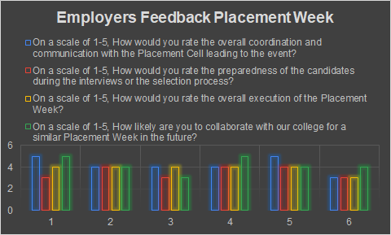

Here are some suggestions during feedbacks:
- Times Of India (Ayaz Shaikh): Students' performance is good. But help us in confirmation with selected students
- Neemtree(Harshali ): Gave suggestion to make sure resume gets uploaded properly.
Note: Companys which gave feedback are
1.Humble servant of God
2.Mass Media Maker
3.Neosoft Technologies
4.Times Of India
5.Neemtree

Students Feedback: We have got feedback of 34 students.
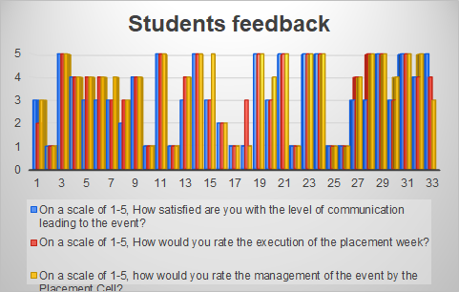
 | Were you successfully able to land a job/internship of your choice? |  | Yes | 19
 |  |  | No | 14
 | Prior to the Placement week, how much of the information that you needed did you get? |  | All the information was provided | 20
 |  |  | Only little information | 8
 |  |  | No information was provided | 5

