Path makers- Explore the journey towards corporate

We are dedicated to help you in journey towards corporate. Ethier students want be entrepreneur, want be employable or explore the options available in the world outside the college, Pathmakers provides the opportunity. The committee works in three dimensions.
- One provides opportunities required by the companies in form of internship or placement throughout the year.
- Second, committee organizes guidance lecture, training program and workshop for CV writing, personal interview, Group discussion and higher studies.
- Third, we try to involve Companies for short term courses, where student get an idea of the field company work with.
Placement 2018-19 in the college.

 | MKS JOBFAIR 2018-19
COMPANIES | Total SELECTED STUDENTS | SELECTED STUDENTS OF MKS
Motilal Oswal | 32 | 22
IIFL | 38 | 16
ANDROMEDA | 4 | 4
SAVAGE AND PALMER | 2 | 2
ICAN | 17 | 10
DIGITAL REPUBLIK | 8 | 3
EULLE ENTERTAINMENT | 35 | 26
GOLDACH | 0 | 0
AVENUE HR | 10 | 7
ARC HR
RANCHO
DMC | 6 | 6

On Campus and off campus Drive
COMPANIES | Students Registered | Selected
Hindustan Times | 41 | Data not recived
Radio Mirchi | 10 | 1
Future Generali | 10 | 6
DJ Acedamy | 6 | 1
Aditya Birla Sales Adcademy | 25 | Data not recived

Feedback from Employers recruiting since last three /four years.

Name of the compa ny | Email | comm unicati on skill | Learni ng Attitu de | Stude nt's Social Aware  ness | Team work | Dyna mism | Decisi onMa king | Confid ence | Emplo yabilit y | Initiati ve
Sanjay Doshi -  Motilal Oswal |  | 5 | 5 | 4 | 5 | 5 | 5 | 5 | 4 | 5
Tristar Management  Services Pvt Ltd |  | 4 | 3 | 3 | 4 | 4 | 3 | 3 | 4 | 3
I-CAN Financial  Solutions |  | 3 | 3 | 3 | 3 | 3 | 3 | 3 | 3 | 3
Iifl Ltd | Ketan. bhatia @iifl.c  om | 4 | 4 | 4 | 3 | 4 | 3 | 2 | 4 | 3
Digital Republ ik | sograh r@digi republi  k.com | 4 | 3 | 3 | 4 | 4 | 3 | 3 | 4 | 3

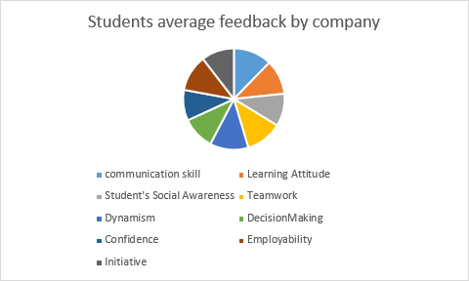

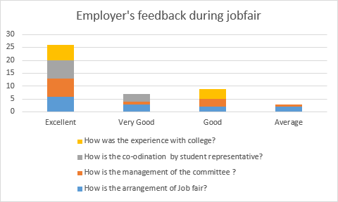

Guidance and career counselling
On 29th September College organized a Business Meet to strengthen the placement cell of our college, where college invited companies and alumni to participate in the event.
A keynote address given by Dr Hanif Kanjer , a founder and director of RustomJi business school

There was a Panel discussion on “campus to corporate” and presentations by the resource person.
Resource persons were
- Ms. Amanpreet Kaur, Asst Vice President, Axis Bank ,
- Prin. Dr. T.P Madhu Nair, Nirmala College & Former Dean, Commerce Faculty, University of Mumbai.
- Assoc Prof. Shri. Balakrishna Parab, Jamnalal Bajaj Institute, Mumbai
- Shi Milind Kulkarni From TATA Power
- The panel discussion conducted by Vice principal Rajesh Dharawat

Alumni Connect and Career guidance
- Alumni Mr Anup Shah (Vice President –Citi bank) also gave talk on “Prerequisites for the Corporate World”.
- Alumni Neha & Hemal Majethia- Co-Founder & Chief OktoMindgave guidance on Importance of choosing the Right Careers choice of career and future opportunities.
- Mr.Shantanu from Bloomberg gave talk on “Recent Trend in job market”
Our training programs
- We organized soft skill workshop facilitated by TATA Power on 17th, 18th and 19th were 153 students participated from various stream. We have got very good feedback from students for the workshop content and its faculties as well from TATA Power faculties for our students and the arrangements provided by college. Thanks to Apurav sir for bringing them here.
- We have introduced another training module for Third year students in association with Techno Serve --an International NGO founded by Citi group .Techno Serve is giving us guarantee of 100% placement if students have 90% attendance in their program. The Key features of this training programs are
- Develop personal and Professional Effectiveness
- Career Readiness-Understand various career options and learn the skills required for them.
- Communication Readiness
- Work Readiness
- One on One Career Counselling
- Placement opportunities in Kotak Mahindra Bank, ICICI Bank, Relaince Group, HDFC life Insurance, Tech Mahindra and few more.

Feedback from students for training program

Manav Mehta | TY BM  S | 103  3 | 9 | 10 | 9 | 10 | 9 | 9 | NA | 9 | 9 | 10 | 9
Jinagn a Shah | TY BM  S | 106  9 | 8 | 9 | 7 | 10 | 7 | 7 | 0 | 8 | 7 | 10 | 9
Nikita Khoda | TY BM  S | 102  7 | 9 | 7 | 9 | 10 | 7 | 9 | 0 | 9 | 8 | 10 | 9
Aakash Panch  al | BF M | 142 | 10 | 9 | 10 | 1 | 10 | 9 | 8 | 10 | 10 | 10 | 10
Jeet Vaisha  nv | TY BM  S | 106  5 | 9 | 9 | 9 | 8 | 9 | 9 | 7 | 9 | 8 | 10 | 9.5
Nidhi  Shah | TY  BBI | 157 | 7 | 8 | 9 | 9 | 9 | 8 | 6 | 8 | - | - | -
Giaan  Jauro | TY  BBI | 162 | 10 | 9 | 8 | 9 | 9 | 8 | 7 | 10 | - | 9 | 9
Nilfer  Memo n | TY BBI | 133 | 7 | 7 | 7 | 7 | 9 | 9 | 6 | 8 | - | 8 | 9
Sara Bhava  n | TY BBI | 171 | 8 | 8 | 8 | 9 | 9 | 7 | 7 | 9 | 10 | 10 | 10
Forum Tank | TY BC O  M | 211  6 | 8 | 8 | 8 | 7 | 8 | 9 | 7 | 8 | 7 | 10 | 8
Nishita Maru | TY BC O  M | 204  3 | 8 | 8 | 8 | 9 | 8 | 7 | 8 | 8 | 7 | 10 | 8
Priyan  ka Patel | TY BC | 206  3 | 9 | 9 | 10 | 8 | 8 | 9 | 10 | 9 | 8 | 9 | 9

O
M
Sneha Pande  y | TY BC  O M | 205  8 | 7 | 6 | 9 | 8 | 7 | 7 | 7 | 9 | 8 | 10 | 9
Devika Panick  ar | TY BBI | 137 | 8 | 8 | 8 | 8 | 9 | 7 | 8 | 9 | 7 | 9 | 10

Some descriptive feedback for training program

Your suggestion for improvement | What do you except from college for better placement
The course is very good | Getting a placement in good place.
Suggestions on self should be provided. | More Job/Companies
No Improvement | Good job as per my likes and dislikes.
It was preety good and intresting and learned a lot. | Good experience company.
No Improvement. It was really good. | Should keep such a sessions to help students
Everything was good .I think best. I learned a lot from  this | Yes,A good job, good salary
Not really needed. Everything was good about it.Learned a lot from this. | Yes,A good job, good salary
- | Crowd Management
- | Crowd Management
- | Crowd Management

Placement Committe students and teachers also takes feedback on regular basis.
Since data file is too large and feedback taken was in descriptive manner we cannot include it here

